
AI-BASED CUSTOMER SUPPORT
AUTOMATION SYSTEM
https://app.aics-050.workers.dev/login
https://github.com/prajitabhandari1234/AI-Based-Customer-Support-Automation-System

Comprehensive Final Project Report
Team Member | Primary Project Responsibility
Prajita Bhandari (12255441) | Backend development and database
Akrishta Ale (12267761) | Frontend development and UI/UX
Ayush Bhandari (S12157470) | AI integration and intelligent automation
October 13, 2026
CQU



Contents
Executive Summary 4
1. Introduction 5
1.1. Report Objectives 5
1.2. Project Evidence and Artefacts 5
2. Project Background and Problem Definition 6
2.1. Problem Statement 6
2.2. Proposed Solution 7
3. Scope, Stakeholders and Success Criteria 7
3.1. In Scope 7
3.2. Out of Scope 7
3.3. Stakeholders and User Roles 8
3.4. Original Success Criteria 8
4. Project Management and Development Process 9
4.1. Team Responsibilities 9
4.2. Meeting and Milestone Workflow 9
4.3. GitHub Workflow and Progress Tracking 9
4.4. Risk Management 11
5. Requirements Engineering and Evolution 12
5.1. Functional Requirements 12
5.2. Non-Functional Requirements 13
5.3. Divergence from Original Requirements and Design 13
6. System Analysis and Design 14
6.1. Use Cases 15
6.2. Component Architecture 16
6.3. Database Design 16
6.4. AI Chat and Escalation Sequence 17
6.5. Ticket Lifecycle 18
7. Implementation of the Final Prototype 19
7.1. Backend Implementation 20
7.2. Authentication and Authorisation 20
7.3. AI and Intelligent Automation 21
7.4. Frontend Implementation 22
7.5. Notifications, Knowledge Base, Analytics and System Logging 23
8. Software Artefacts and Refinement 23
9. Testing and Quality Assurance 24
9.1. Backend Automated Testing 25
9.2. Frontend Unit and Integration Testing 26
9.3. Integration and End-to-End Testing 27
9.4. Performance and Reliability Testing 27
9.5. Testing Against Project Risks 27
10. Docker, Containerisation and Production Deployment 28
10.1. Local Containerisation 28
10.2. Nginx Reverse Proxy 28
10.3. Azure Deployment 28
10.4. Cloudflare Public URL 28
10.5. Deployment Problems and Refinement 29
11. Evaluation of the Final Solution 30
11.1. Strengths of the Final Design 30
11.2. Limitations 31
12. Ethical, Security and Professional Considerations 31
12.1. Privacy and Data Minimisation 31
12.2. AI Reliability, Transparency and Human Oversight 31
12.3. Prompt Injection and Scope Control 31
12.4. Credential and Secret Management 32
12.5. Professional Practice 32
13. Problems Encountered and Resolutions 32
14. Final Project Outcomes 33
15. Future Improvements 33
16. Conclusion 34
17. References 35
Appendix A – Final Technology and Artefact Inventory 37
Appendix A.1 Key Production Configuration Files 37
Appendix B – Requirement Traceability Summary 37
Appendix C – Selected API Surface 38
Appendix D – Deployment and Submission Checklist 39

Executive Summary
This report presents the development progress and current prototype of the AI-Based Customer Support Automation System, developed as a group enterprise application for COIT13230 Application Development Project. The system is designed to improve customer-support efficiency by combining AI-assisted responses with structured ticket management and human-agent escalation. The current prototype integrates a React frontend, Java Spring Boot REST backend, relational database, JWT-based role security, AI-assisted chatbot, automated ticket classification and prioritisation, sentiment and confidence analysis, notifications, knowledge-based management, analytics, and system logging.
The project progressed through requirements analysis, system design, parallel development, integration, testing, refactoring and deployment. Development was coordinated through GitHub, using separate backend, AI and frontend branches, incremental commits, issues and pull requests before integration into the shared main branch.
The implemented prototype supports three primary user roles: Client, Support Agent and Administrator. Clients can register and authenticate, interact with the AI-assisted chatbot, create and monitor support tickets, review conversation history and receive support responses. Support agents can manage escalated tickets, review customer conversations, respond to customers and update ticket status. Administrators can manage users and roles, maintain knowledge-based content, review analytics and access system activity logs. AI-assisted processing supports ticket categorisation, prioritisation, sentiment detection, confidence assessment and escalation decisions, while human agents remain involved when automated support is insufficient.
The system can run locally, through Docker Compose, or in its deployed cloud environment. The deployed solution uses containerised frontend and backend services, MySQL persistence and production routing through Nginx and a public application endpoint. During integration, issues involving frontend-backend data handling, AI-provider availability, resource ownership, role-based access and production routing/CORS were identified and addressed.
Testing covers authentication and role-based access, customer chat and ticket workflows, AI decision logic, agent and administrator operations, resource ownership, API behaviour and frontend-backend integration. The project contains backend, frontend, integration, system, end-to-end and performance-testing assets. Changes from the original requirements and design, including adoption of React and Vite, H2 support for local development and testing alongside MySQL, structured AI analysis, local AI fallback behaviour, an expanded ticket lifecycle and broader automated testing, are documented in this report.
Overall, the current prototype demonstrates substantial progress toward the original project objectives and provides an integrated, secure and deployable AI-assisted customer-support system for the Assessment 3 prototype demonstration.

Introduction
Customer support systems need to provide timely, accurate and consistent assistance while allowing support staff to focus on more complex customer issues. Many common enquiries, including account problems, product information, order tracking, password resets and basic troubleshooting, are repetitive and time-consuming when handled entirely by support staff. The original project proposal identified that these manual processes could contribute to longer response times, increased staff workload and inefficient ticket handling. It therefore proposed using AI and automation to improve customer-support efficiency while maintaining human involvement for more complex cases. (Følstad and Skjuve, 2019; Olujimi and Ade-Ibijola, 2023)
The AI-Based Customer Support Automation System was developed to address these challenges through an intelligent web-based platform. The system combines AI-assisted customer chat, automated ticket creation and management, ticket classification and prioritisation, sentiment analysis, confidence assessment and human escalation. AI is used to provide first-line assistance and support routing decisions rather than replacing support staff. When an enquiry cannot be resolved automatically or requires human involvement, it can be escalated to a support agent while retaining the relevant conversation and ticket information. This reflects the original proposal's goal of balancing AI automation with human support.
The current prototype has progressed from the original proposal and system design into an integrated enterprise web application supporting Client, Support Agent and Administrator roles. This report presents the current project progress for Assessment 3, focusing on the implemented user stories, interfaces, features and business logic, key implementation components, GitHub progress tracking, integration and automated testing, problems encountered during development, and documented changes from the original requirements and design.

Report Objectives
The objectives of this report are to:
- Describe the current progress and status of the AI-Based Customer Support Automation System.
- Present the user stories, interfaces, features and business logic implemented in the current prototype.
- Explain the key implementation of the frontend, backend, AI integration, database and security components.
- Demonstrate project progress and team coordination through GitHub branches, commits, pull requests, issues and meeting records.
- Present integration and automated testing results for the major implemented workflows.
- Identify significant errors and problems encountered during development and explain how they were addressed.
- Document any divergence from the original requirements and system design as the project developed.
- Evaluate the current integrated prototype against the original project objectives and success criteria.

Project Evidence and Artefacts
This report is supported by project documentation, source code, testing evidence, GitHub development history and the current integrated prototype. These artefacts provide evidence of the project's progression from the original proposal and requirements through implementation, integration, testing and deployment.
Project Artefact | Use in this Report
Group Project Proposal | Defines the original project problem, scope, objectives, stakeholders, success criteria, risks and planned functionality.
System Analysis and Design | Provides the functional and non-functional requirements, use cases, system architecture, database design and UML models.
Progress Reports 1 and 2 | Demonstrate development progress, implementation decisions, individual contributions, integration activities and testing preparation.
Task and Project Division | Identifies team responsibilities across frontend, backend, database, AI integration, testing and documentation.
Meeting Minutes | Provide evidence of team coordination, development decisions, milestones, integration, testing, refactoring and deployment activities.
Final Source Code | Provides evidence of the implemented React frontend, Spring Boot backend, database persistence, security, AI integration and application features.
Testing Artefacts | Provide evidence of backend, frontend, integration, system and end-to-end testing of the implemented functionality.
GitHub Repository | Demonstrates development history through branches, commits, issues, pull requests and integration into the main branch.
Current Integrated Prototype | Demonstrates the implemented CLIENT, AGENT and ADMIN workflows and overall frontend-backend-AI integration.
Assessment 3 Specification | Defines the required evidence for implemented functionality, implementation details, testing, problems, design divergence and project tracking.

Project Background and Problem Definition
The original project proposal identified a common customer-support problem: organisations receive large numbers of repetitive enquiries while still relying heavily on support staff to manually read, classify, prioritise and respond to customer requests. This can increase response times and staff workload, produce inconsistent responses, make urgent issues more difficult to identify, and limit the organisation's ability to analyse customer-support trends. (Olujimi and Ade-Ibijola, 2023; Zangari et al., 2023)
To address these problems, the project proposed an AI-Based Customer Support Automation System that combines automated assistance with a structured support-ticket workflow. The objective was not simply to develop a chatbot, but to create an integrated system capable of analysing customer enquiries, providing automated responses, managing support tickets and escalating appropriate cases to human agents.
The implemented prototype extends this approach through ticket categorisation, priority assignment, sentiment analysis, AI confidence assessment and escalation decisions. Customer conversations, messages, tickets and related support information have persisted so that clients, support agents and administrators can participate in the same support workflow. This enables AI to assist with routine enquiries while maintaining human involvement for complex or unresolved customer issues.

Problem Statement
The practical problem addressed by this project is the inefficiency of traditional customer-support processes when handling large numbers of repetitive enquiries. Manual processing can increase response times and staff workload while making ticket classification, prioritisation and identification of urgent customer issues more difficult. The project therefore investigates how AI-assisted automation can provide timely support for common enquiries while maintaining human intervention for complex or unresolved cases and preserving structured information for support staff and administrators.

Proposed Solution
The original proposal defined a web-based AI-Based Customer Support Automation System that combines automated customer assistance with ticket management and human-agent support. The proposed solution includes:
- A browser-based customer interface supporting registration, secure login, AI-assisted chat and ticket tracking.
- Automated analysis of customer enquiries for ticket category, priority, sentiment and AI confidence.
- A knowledge base to support consistent responses to common customer enquiries.
- Intelligent human escalation when AI confidence is low, sentiment is negative, an issue is urgent or complex, or human assistance is required.
- A support-agent workflow for reviewing escalated and assigned tickets, conversation history, customer responses and ticket status.
- Administrative functionality for user management, knowledge-based management, analytics, reporting and system monitoring.
- Persistent relational storage for customer-support information with secure role-based access.
- An integrated web application capable of supporting the complete workflow between Client, Support Agent and Administrator.

Scope, Stakeholders and Success Criteria

In Scope
The original project scope focused on developing a web-based AI-assisted customer-support system. During implementation, several supporting features were added or refined to complete the integrated workflow. The current project scope includes:
- Web-based user registration, authentication and role-based access.
- AI-assisted customer chat for common support enquiries.
- Customer support ticket creation, management and status tracking.
- Automated ticket classification and priority assignment.
- Sentiment analysis and AI confidence scoring to support automated decisions.
- Human escalation and agent assignment for issues requiring manual assistance.
- Customer and support-agent notifications.
- Knowledge-based management for authorised staff.
- Administrator functionality including user management, analytics, reporting and system logs.
- Persistent relational data storage using H2 for local development/testing and MySQL for Docker/production environments.
- Docker-based containerisation and cloud deployment of the integrated application.

Out of Scope
The original proposal excluded several features because of the available semester timeframe and project resources. These included:
- Native mobile applications.
- Voice-based AI assistance.
- Video-based customer support.
- Multilingual support.
- Financial transactions or payment processing.
These features remain outside the current prototype and may be considered as future extensions. This is consistent with the original proposal, which explicitly excluded smartphone development, voice AI, video support, multilingual functionality and payment-processing integration.

Stakeholders and User Roles
The project involves both direct system users and broader stakeholders who are affected by the operation and outcomes of the customer-support platform. The three primary system roles are CLIENT, AGENT and ADMIN, supported by business, development and external AI-service stakeholders.
Stakeholder / Role | Main Need | Final System Support
Customer / CLIENT | Fast and accessible support, clear ticket status and access to human assistance when required. | AI-assisted chat, ticket creation and tracking, conversation history, agent responses and notifications.
Support Agent / AGENT | Prioritised customer issues with sufficient information to investigate and resolve them. | Escalated and assigned ticket views, conversation history, customer replies, status updates and knowledge-base access.
Administrator / ADMIN | Control, security and visibility across the support system. | User and role management, analytics, reports, knowledge-based management and system logs.
Business Owner / Organisation | Improved customer-support efficiency and better understanding of service performance. | Aggregated analytics, ticket categories and priorities, escalation information, customer-support trends and resolution data.
Development Team | A maintainable, secure and testable application that can be integrated and extended. | Modular frontend and backend components, documented APIs, database persistence, automated testing and containerised deployment.
AI Service Provider | Reliable integration between the application and external AI capabilities. | Isolated AI-provider integration with structured AI processing and fallback behaviour when the external provider is unavailable.
The three application roles correspond directly with the user roles defined in the original proposal:
- Clients: who access automated support and submit requests
- Support Agents: who manage escalated customer issues
- Administrators: who manage the platform and monitor system performance.

Original Success Criteria
The original project proposal defined success through the delivery of a functional and reliable customer-support prototype. The project would be considered successful if users could register and log in securely, the AI chatbot could provide appropriate responses to common customer enquiries, customers could create and monitor support tickets, and support agents could view, manage, respond to and resolve customer issues. The proposal also required an administrator dashboard for monitoring service performance, useful analytics and reporting information, and reliable system operation that met the expected quality requirements.
Figure 1: Project evolution from proposal to production deployment.

Project Management and Development Process
The project was divided into three main development streams: backend and database, AI and intelligent automation, and frontend/UI. This allowed team members to work in parallel while maintaining clear responsibilities. Development progressed from proposal and requirements planning into implementation, integration, testing, refactoring and deployment. GitHub issues, branches, commits and pull requests, together with regular team meetings, were used to track progress and coordinate integration.

Team Responsibilities
Team Member | Primary Responsibility | Examples of Contribution
Prajita Bhandari | Backend and Database | Spring Boot REST APIs, database persistence, authentication and security, user and ticket management, analytics and backend integration.
Akrishta Ale | Frontend and UI/UX | React application, pages and reusable components, API integration, frontend refactoring and UI testing.
Ayush Bhandari | AI Integration and Intelligent Automation | AI service integration, structured message analysis, ticket classification, sentiment and confidence analysis, escalation logic, fallback handling and AI testing.
The division of responsibilities supported independent development while requiring regular integration between the three components to produce the final working prototype.

Meeting and Milestone Workflow
The team conducted regular meetings throughout the project to review progress, allocate tasks and identify integration issues. Early meetings focused on the proposal, requirements, system design and project planning. As development progressed, the focus moved toward frontend, backend and AI implementation.
Later meetings concentrated on system integration, refactoring and testing. The final development stage focused on resolving frontend-backend integration issues, completing automated tests and documentation, and preparing the integrated application for deployment. Meeting records therefore provided evidence of project decisions, completed milestones, outstanding tasks and changes in development priorities.

GitHub Workflow and Progress Tracking
GitHub was used as the main development and project-tracking platform. Separate backend, AI and frontend branches supported parallel development, while completed work was progressively integrated into the main branch through commits and pull requests. The repository records demonstrating continuous development across requirements, design, implementation, integration, testing, refactoring and deployment preparation.
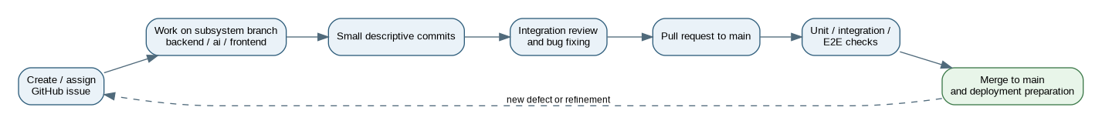
Figure 2: GitHub branch, pull-request and integration workflow used during project development.
GitHub Issues were also used to convert project requirements and development activities into trackable tasks. As shown in Figure 3, early issues covered activities such as the project problem statement, scope and objectives, stakeholder analysis, system roles, functional and non-functional requirements, product backlog, user stories and risk management. Priority and category labels were used to organise the work, and completed tasks were closed as development progressed.
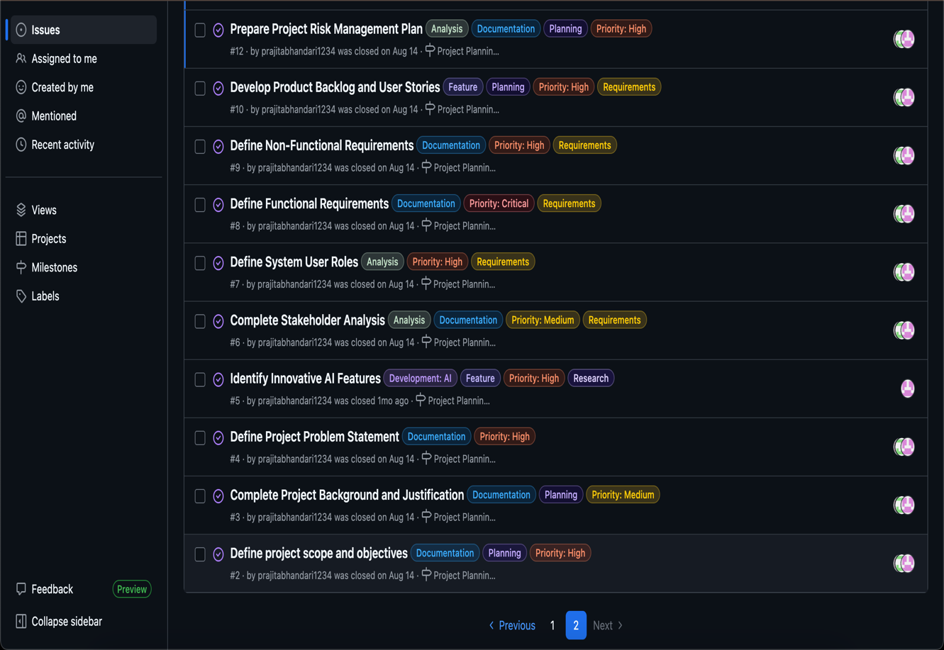
Figure 3: Closed GitHub Issues showing requirements, planning and project-tracking activities.
Later GitHub activity tracked implementation, integration and testing tasks across the backend, AI and frontend components. The commit history provides additional evidence of incremental development, testing, Javadoc documentation, frontend refactoring, integration and deployment preparation.
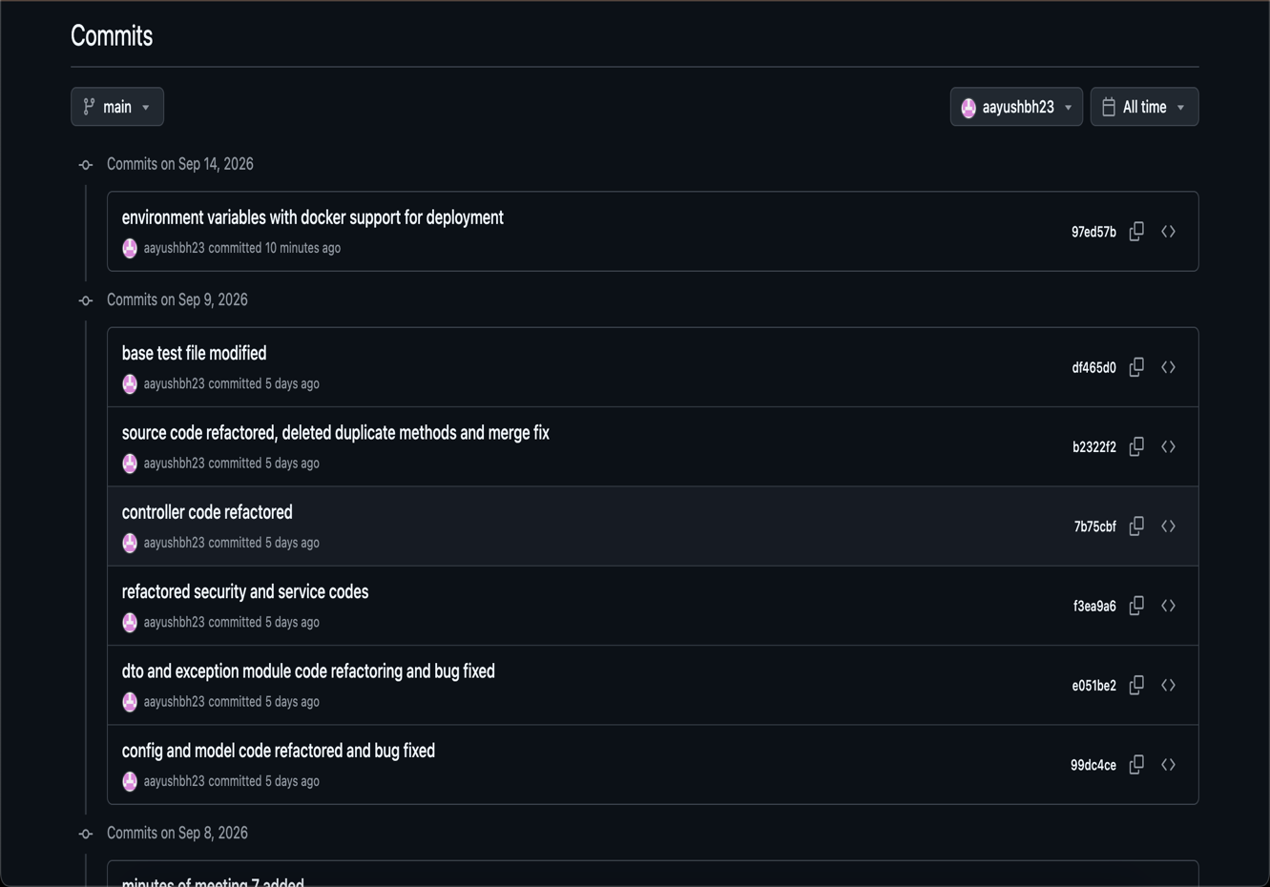
Figure 4: GitHub commit history showing later testing, refactoring and deployment activities.

Risk Management
Project risks were identified and evaluated according to their likelihood and impact. The risk register covered technical, AI-service, integration, schedule, security and project-management risks, including AI API availability, API rate limits, team availability, schedule delays, frontend-backend-AI integration, database failure, security vulnerabilities, AI response accuracy, internet connectivity, requirement changes, software defects and source-code loss.
Mitigation and contingency strategies were defined for each risk. Examples included using AI fallback mechanisms, conducting regular GitHub commits, performing continuous integration and testing, maintaining database backups, applying authentication and validation controls, and monitoring project progress through meetings and GitHub Issues. The risk register was reviewed as development progressed so that emerging issues could be addressed before they significantly affected the project.
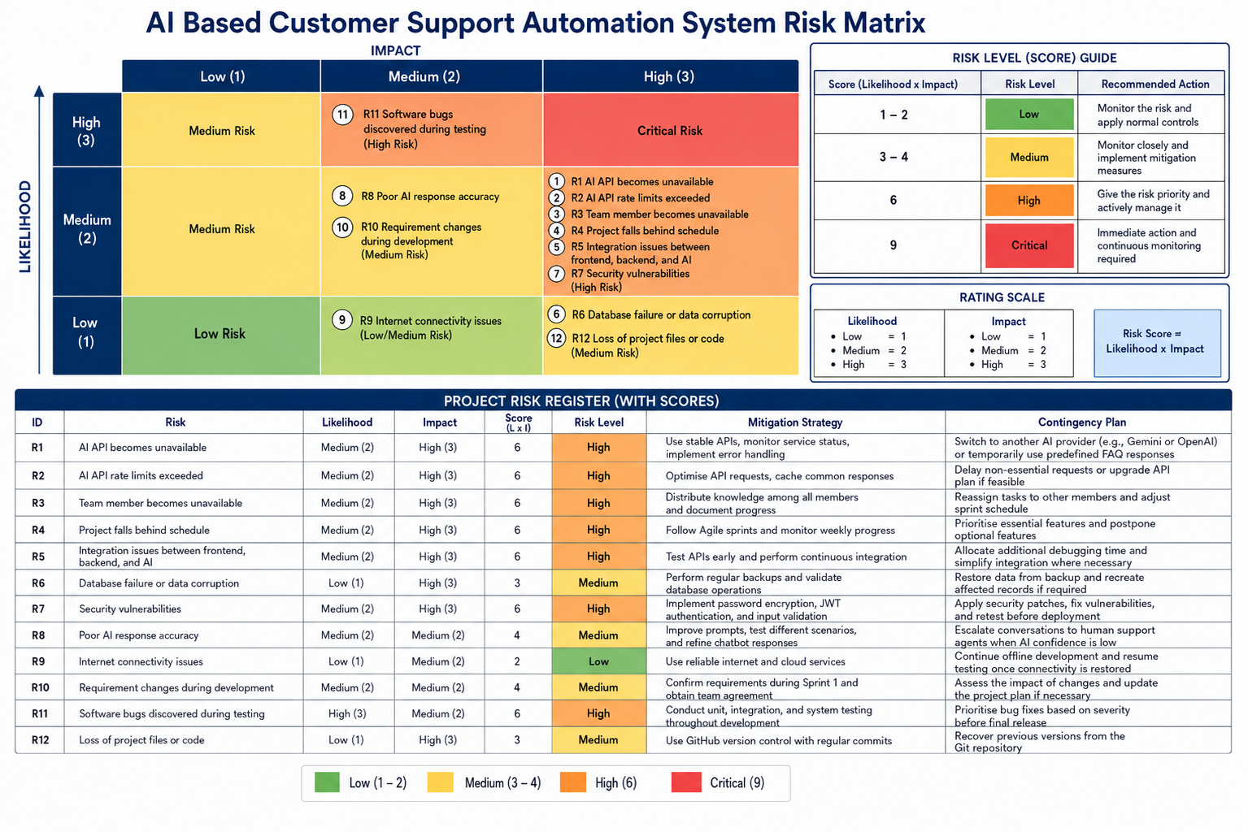
Figure 5: Project risk matrix and risk register showing likelihood, impact, mitigation and contingency strategies.

Requirements Engineering and Evolution
The project requirements were initially established in the proposal and later refined into detailed functional and non-functional requirements during system analysis and design. These requirements guided development across authentication, AI-assisted chat, ticket management, escalation, knowledge-based management, analytics, security and system reliability. As implementation progressed, some technical and design decisions were refined to support integration, testing and deployment.

Functional Requirements
The functional requirements defined the major behaviours expected from the system. The current prototype implements the main requirement areas as follows:
Requirement Area | Requirements | Implementation Outcome
Authentication and Roles | FR1, FR29–FR32 | Registration and login with JWT authentication, CLIENT/AGENT/ADMIN roles and role-protected functionality.
AI-Assisted Chat | FR2–FR7 | Customer chat, AI-assisted responses, conversation history and persistent messages.
Ticket Management | FR8–FR14 | Manual and automated ticket creation, categorisation, priority, status management and ticket history.
Sentiment and Confidence | FR15–FR17 | Sentiment analysis, confidence scoring and identification of cases requiring further attention.
Human Escalation | FR18–FR22 | Escalation rules, agent assignment, notifications, agent responses and resolution workflow.
Knowledge Base | FR23–FR25 | Knowledge-based storage, staff CRUD functionality and support for AI-assisted responses.
Analytics and Reporting | FR26–FR28 | Support metrics, filtering, reporting and an administrator analytics interface.
System Logging | FR33 | Persistent system activity logs available to administrators.
These requirements extend the functionality identified in the original proposal, which included authentication, AI-assisted support, ticket management, classification, sentiment analysis, escalation, analytics and role-based functionality.

Non-Functional Requirements
Non-functional requirements guided the expected quality, security, reliability and maintainability of the application.
Quality Area | Requirement Intent | Implemented Response
Performance | Provide responsive customer-support interactions, with chatbot responses targeted below three seconds under normal conditions. | AI request timeout handling and performance-testing assets were introduced to support performance evaluation.
Reliability | Handle invalid requests and external-service failures safely. | Input validation, centralised exception handling, request timeouts and local AI fallback behaviour.
Security | Protect user credentials and restrict privileged functionality. | BCrypt password hashing, JWT authentication, role-based access control, CORS configuration and environment-based configuration.
Usability | Provide clear interfaces appropriate to each user role. | React-based interfaces, reusable components and role-aware navigation.
Extensibility | Allow components and external services to be modified or extended. | Layered backend architecture, separated services and configurable AI-provider integration.
Maintainability | Maintain readable, modular and documented source code. | Controller-service-repository separation, Javadocs, API documentation, testing and code refactoring.

Divergence from Original Requirements and Design
During development, several implementation and design decisions evolved from the original proposal. These changes did not alter the core purpose of the project but helped improve integration, reliability, maintainability and deployment.
Original Requirement / Design | Final Implementation | Reason / Effect
Generic HTML/CSS/JavaScript frontend | React 19 with Vite | Improved component reuse, routing, interface organisation and frontend-backend integration.
External AI service as the main intelligent path | External AI integration with deterministic local fallback | Reduced dependency on external API availability and improved reliability during development and demonstration.
AI primarily producing chatbot responses | Structured AI analysis including reply, category, priority, sentiment, confidence and escalation information | Allowed AI results to support ticket-processing and escalation business logic.
Basic ticket-focused data model | Conversation, Message, Notification and SystemLog added as persistent entities | Supported conversation history, notifications and system activity tracking.
Relational database implementation | H2 for local development/testing and MySQL for Docker/production | Simplified local development and automated testing while retaining MySQL for deployed operation.
General deployment approach | Docker-based cloud deployment with production routing | Improved portability and enabled access to the integrated deployed prototype.
Initial testing approach | Expanded backend, frontend, integration, system and end-to-end testing | Provided repeatable verification of security, business rules and integrated workflows.
The main functional goals of the original project remained unchanged. The changes primarily affected technology selection, data modelling, AI integration, testing and deployment, while preserving the intended customer-support workflow of automated assistance, ticket management and human escalation.

System Analysis and Design
The system follows a layered client-server architecture that separates the user interface, application logic, data persistence and AI-processing responsibilities. The React frontend provides role-specific interfaces for clients, support agents and administrators, while the Spring Boot backend exposes REST APIs and manages authentication, business rules, ticket processing and persistence. JPA repositories provide relational data access, with H2 supporting local development and testing and MySQL supporting Docker and production environments.
AI-assisted processing is separated within the service layer. Customer messages can be analysed for category, priority, sentiment, confidence and escalation requirements, while knowledge-based information and fallback behaviour support continued operation when appropriate. This architecture extends the original proposal while maintaining its central objective of combining automated customer assistance with structured ticket management and human support.
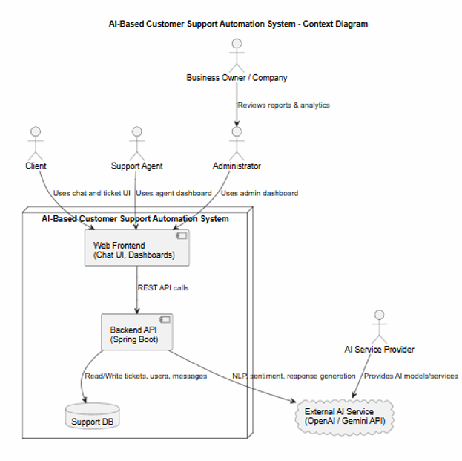
Figure 6: System context diagram showing the primary users, application components, database and external AI service.

Use Cases
The system Use cases represent the major interactions identified in the functional requirements. The three primary roles are CLIENT, AGENT and ADMIN. Clients can register, authenticate, communicate through AI-assisted chat, create support tickets and monitor ticket status. Support agents can review escalated tickets, access conversation information, respond to customers and update ticket status. Administrators can manage users and roles, maintain knowledge-based information and review analytics.
Supporting AI-related use cases include ticket classification, priority assignment, sentiment analysis, confidence assessment and human escalation. Together, these use cases represent the complete workflow from an initial customer enquiry through automated assistance and, where required, human support.
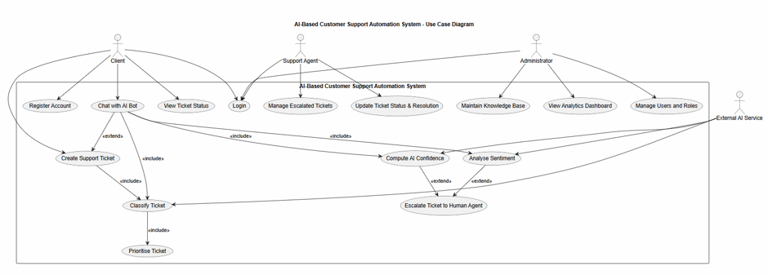
Figure 7: Use case diagram showing client, support-agent, administrator and AI-service interactions.

Component Architecture
The component architecture separates the system into presentation, application and data layers. The presentation layer contains the React interfaces used by clients, support agents and administrators. These interfaces communicate with the Spring Boot backend through REST APIs.
The application layer contains services responsible for authentication and user management, ticket management, AI/chat processing, knowledge-based operations and analytics. The persistence layer uses JPA repositories to store and retrieve application data. External AI functionality is accessed through the AI-processing service rather than directly from the frontend, keeping AI-provider communication separated from the user interface.
The final implementation follows this layered approach through backend packages for controllers, DTOs, models, repositories, services, security, configuration and exception handling, while the frontend separates pages, reusable components, authentication, API communication, configuration and utilities.
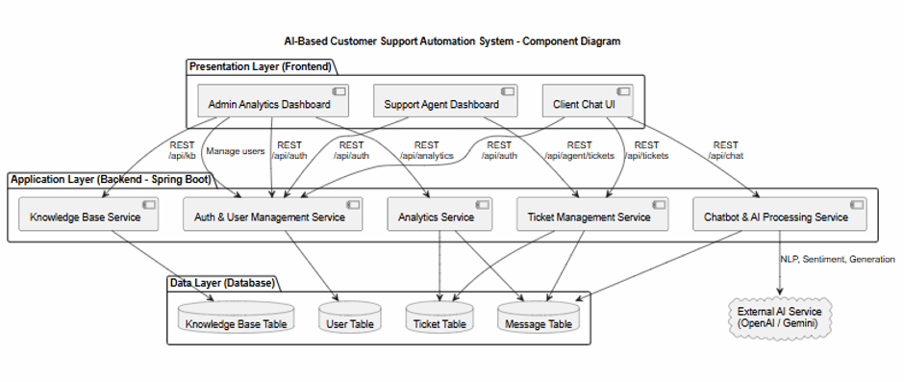
Figure 8: High-level component architecture of the AI-Based Customer Support Automation System.

Database Design
The database design supports persistent storage of the complete customer-support workflow. The final data model contains the main entities User, Conversation, Message, Ticket, KnowledgeBaseEntry, Notification and SystemLog.
A user can participate in conversations and tickets, while messages preserve communication history. Tickets store information including category, priority, status, sentiment score, AI confidence score, resolution notes and agent assignment. Knowledge-based entries store reusable support information, notifications communicate relevant ticket events to users, and system logs provide administrative records of important application activities.
The final data model therefore extends the simpler ticket-oriented concept from the original proposal and provides the information required to support chat history, ticket processing, human escalation, notifications and administrative monitoring.
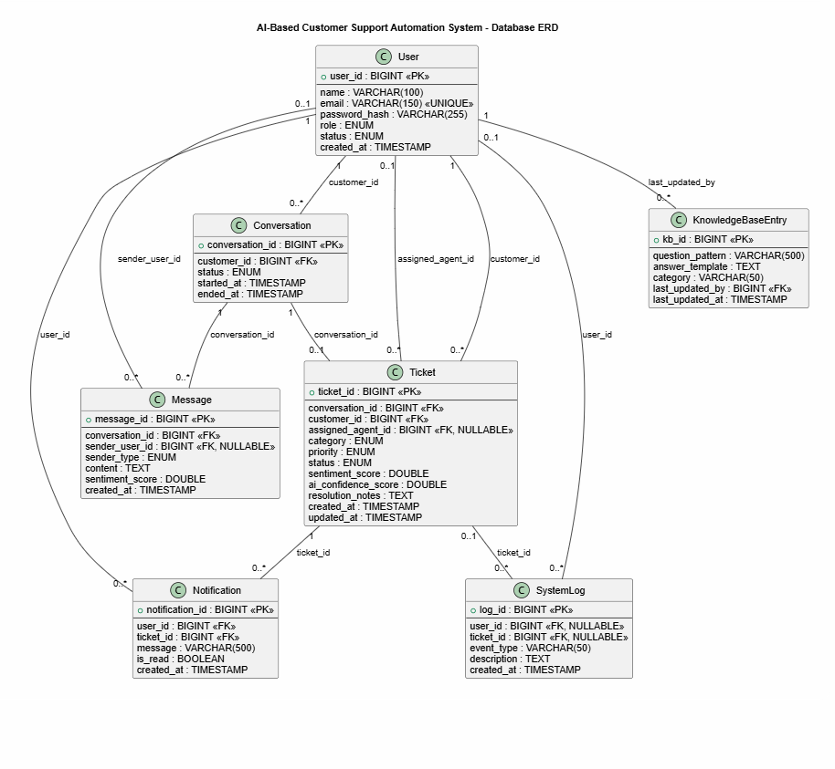
Figure 9: Entity relationship diagram showing the final persistent data model and major entity relationships.

AI Chat and Escalation Sequence
The AI-assisted support workflow begins when an authenticated client submits a message through the chat interface. The backend processes the message and can use available knowledge-based information and AI analysis to determine an appropriate response.
Where automated support is appropriate, the system returns an AI-assisted response to the client. The analysis can also contribute information such as ticket category, priority, sentiment and confidence. When business rules determine that human intervention is required, the issue can be escalated into the support-ticket workflow so that an agent can review the conversation and continue assisting the customer.
This sequence demonstrates that AI is used as part of the wider support workflow rather than operating as an independent chatbot. Relevant customer and ticket information is retained so that an escalated issue can continue from automated assistance to human support without losing its context.
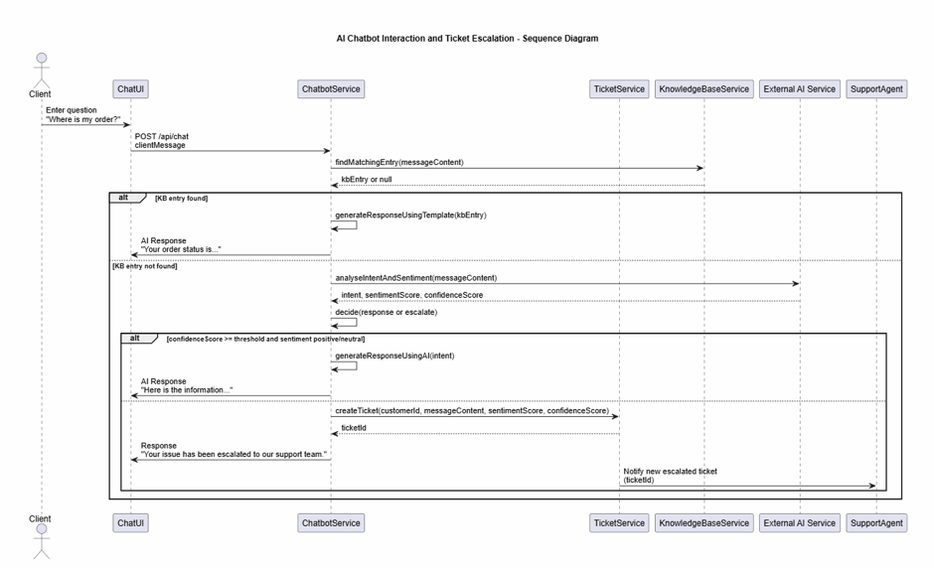
Figure 10: Sequence diagram showing AI-assisted chat, knowledge-base processing and escalation to human support.

Ticket Lifecycle
The ticket lifecycle was refined during implementation to represent both automated and human-assisted resolution paths.
Not every ticket must pass through every status. For example, an issue successfully handled through automated assistance may reach RESOLVED, while an issue requiring human assistance can be escalated and progressed through agent handling before being marked RESOLVED or CLOSED.
The activity diagram demonstrates the broader business process. A customer enquiry first receives automated assistance where appropriate. If further support is required, a ticket can be created and enriched with classification, priority, sentiment and confidence information. Escalated tickets can then be assigned to a support agent, who reviews the available history, communicates with the customer and updates the ticket until resolution.
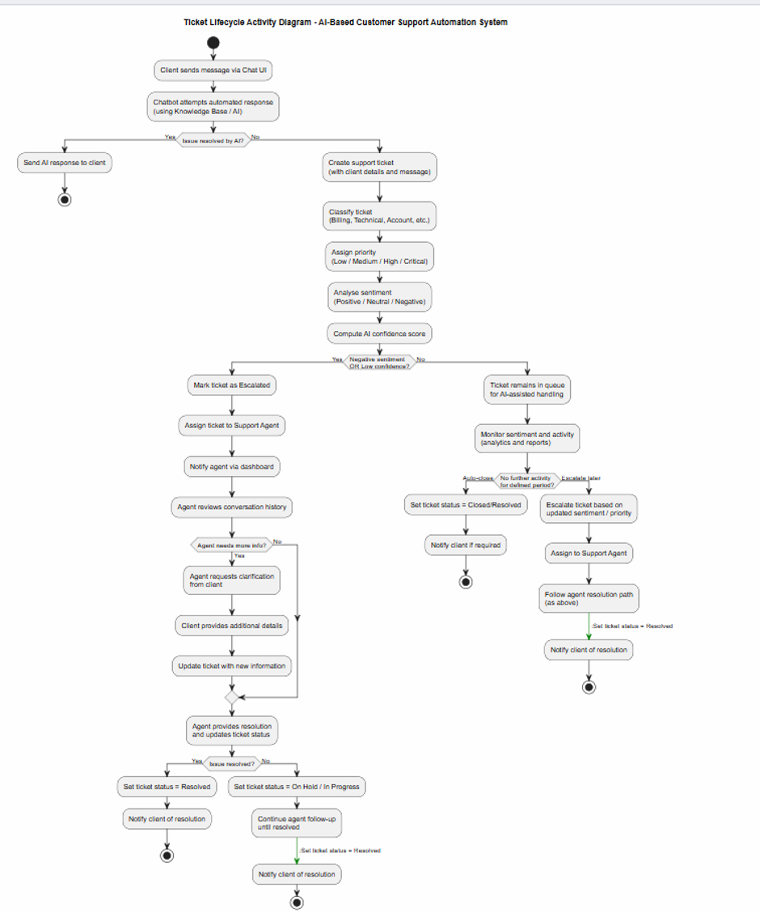
Figure 11: Ticket lifecycle activity diagram showing automated and human-assisted support paths.
The state-machine diagram provides a more concise representation of the ticket's possible state transitions, including classification, analysis, escalation, agent handling, resolution and closure.
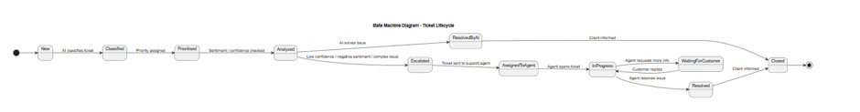
Figure 12: Ticket state-machine diagram showing the major ticket status transitions.

Implementation of the Final Prototype
The final prototype integrates the React frontend, Spring Boot backend, relational database, AI-processing services and security components into a single customer-support workflow. The implementation follows the layered design described in Section 6, with REST APIs connecting the frontend to backend services and JPA repositories managing persistent application data.
The implemented system supports the three primary roles: CLIENT, AGENT and ADMIN and provides functionality for authentication, AI-assisted chat, ticket management, human escalation, notifications, knowledge-based management, analytics, user administration and system logging.

Backend Implementation
The backend is implemented using Java and Spring Boot. It follows a layered architecture in which controllers receive HTTP requests, services implement business logic, repositories provide database access, and DTOs define the information exchanged through the REST API.
Backend Layer | Purpose | Examples
Controllers | Handle REST requests and coordinate application workflows. | AuthController, ChatController, CustomerTicketController, AgentTicketController, AnalyticsController
Services | Implement business logic and coordinate system components. | TicketService, AiService, OpenAiService, NotificationService, AnalyticsService
Repositories | Provide JPA-based database access and queries. | UserRepository, TicketRepository, MessageRepository, SystemLogRepository
Models | Represent persistent entities and application states. | User, Ticket, Conversation, Message, KnowledgeBaseEntry, Notification, SystemLog
Security | Provide authentication, token validation and access control. | JwtService, JwtAuthenticationFilter, SecurityConfig
DTOs and Exceptions | Validate API input and provide consistent request, response and error structures. | ChatMessageRequest, LoginRequest, TicketDetailResponse, GlobalExceptionHandler
The backend exposes REST endpoints for the major system functions, including authentication, customer chat, tickets, conversations, notifications, knowledge-base operations, agent workflows, analytics, system logs and administrator user management. This structure keeps responsibilities separated and supports maintainability and testing.

Authentication and Authorisation
The application implements authentication and authorisation using Spring Security, JSON Web Tokens (JWT) and BCrypt password hashing. Users authenticate through the login API and receive a JWT that is included with subsequent protected API requests. Passwords are stored as BCrypt hashes rather than plain text.
Role-based access control separates functionality between CLIENT, AGENT and ADMIN users. Clients access customer-support functionality, agents access staff ticket-management functions, and administrators access privileged features such as user management, analytics and system logs.
Security is enforced at both the frontend and backend. The React application uses protected routes and role-aware navigation to control the interfaces presented to each user. However, the backend remains the final authority and validates authentication and role permissions before allowing access to protected resources.
Public registration is restricted to the CLIENT role, while privileged AGENT and ADMIN accounts are managed through administrator functionality. This prevents a public user from registering directly with elevated privileges.
Figure 14. Spring Security and JWT configuration implementing authentication and role-based access control.

AI and Intelligent Automation
AI functionality is separated from the main ticket-management logic through dedicated services. OpenAiService manages communication with the external AI provider, while AiService coordinates application-specific AI processing, knowledge-base support, structured analysis and fallback behaviour.
Customer enquiries can be analysed to produce information used by the wider support workflow:
AI Output | Implementation Behaviour
Category | Classifies the enquiry into an appropriate support category.
Priority | Assigns LOW, MEDIUM, HIGH or CRITICAL priority.
Sentiment | Identifies POSITIVE, NEUTRAL or NEGATIVE customer sentiment.
Confidence | Provides a confidence value used with application business rules.
Escalation | Indicates whether human support is required and records relevant escalation reasons.
Response | Generates an appropriate customer-facing support response.
The structured AI result is important because AI output is not treated only as chatbot text. The resulting category, priority, sentiment and confidence information can contribute to ticket creation, prioritisation and escalation decisions.
The system also provides fallback behaviour when the external AI service is unavailable or unsuitable for processing the request. This improves reliability and reduces the prototype's dependency on continuous external AI-service availability.
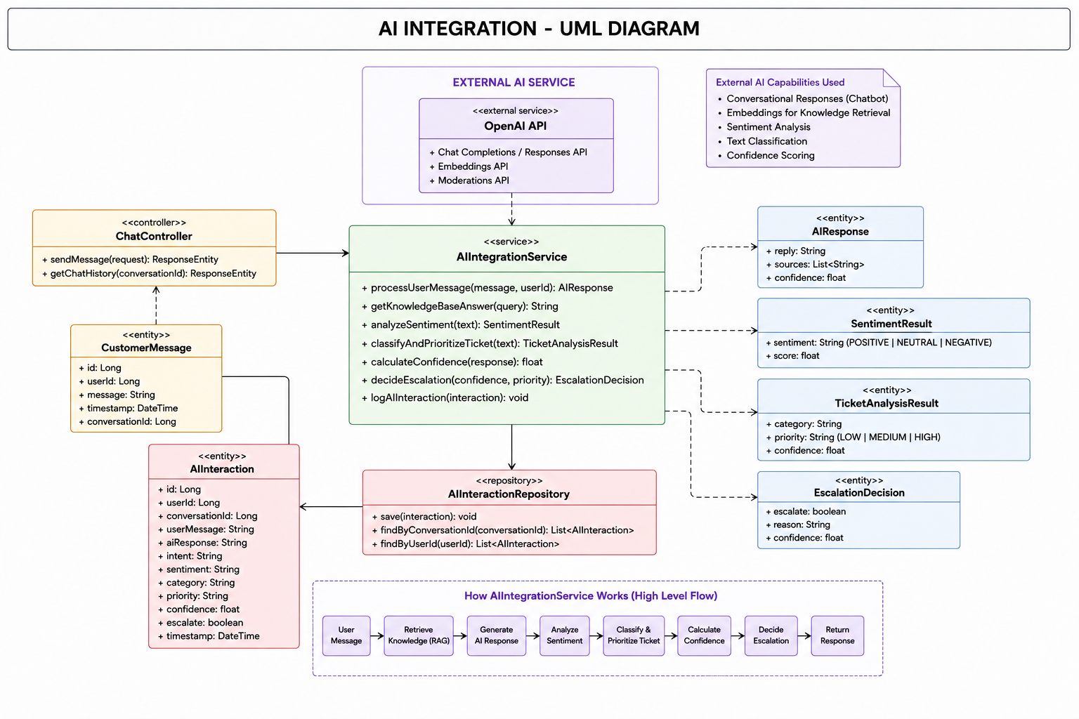
Figure 13: AI integration design showing the relationship between chat processing, AI services, structured analysis and external AI functionality.

Frontend Implementation
The frontend is implemented using React 19 and Vite and provides role-specific interfaces for clients, support agents and administrators. React Router manages navigation, while protected routes restrict pages according to authentication status and user role.
The main frontend interfaces include:
Route / Interface | Role | Purpose
/login, /register | Public | User authentication and customer registration
/home | Authenticated | Role-aware application landing page
/chat | CLIENT | AI-assisted customer-support conversation
/tickets | CLIENT | View customer support tickets
/tickets/new | CLIENT | Create a new support ticket
/tickets/:id | Authenticated | View ticket details and conversation history
/staff | AGENT / ADMIN | Review and manage support tickets
/analytics | ADMIN | View support metrics and reports
/knowledge | AGENT / ADMIN | Maintain knowledge-base information
/users | ADMIN | Manage users and roles
/logs | ADMIN | Review system activity
A central API layer manages communication between React and the Spring Boot backend. It attaches the authenticated user's JWT to protected requests, processes API responses and handles authentication failures. Reusable components and normalisation utilities were introduced during integration to improve consistency between frontend pages and backend response structures.
This refactoring was particularly important when the frontend moved from development data to the actual backend APIs.

Notifications, Knowledge Base, Analytics and System Logging
Several supporting modules were implemented to complete the customer-support workflow.
The notification system informs users about relevant ticket events. Customers can receive notifications when support activity occurs, while support agents can be notified when cases require human attention. Notification records persisted so that unread and previously viewed notifications can be managed by the application.
The knowledge base stores reusable support information that can assist with predictable customer enquiries. Authorised staff can maintain knowledge-base entries, while the AI/chat workflow can use relevant knowledge when processing customer requests.
The analytics module provides administrators with information about support activity, including ticket counts, categories, priorities, escalation information and resolution-related metrics. Reporting functionality supports monitoring of system and support performance.
Finally, system logging records important application activities such as authentication events, ticket creation, escalation and relevant AI-processing events. These records provide administrators with additional visibility into significant system activity.
Together, these supporting modules extend the application beyond a basic chatbot and provide a more complete customer-support management platform.

Software Artefacts and Refinement
The project documentation and supporting software artefacts were progressively refined alongside implementation. The original proposal and system-design documents established the initial requirements and architecture, while development, integration and testing identified areas that required additional documentation and technical detail.
As the prototype became more complete, the project artefacts were updated to reflect the implemented API structure, AI integration, database model, testing approach, source-code documentation and deployment environment. This helped maintain consistency between the documented design and the final integrated system.
Artefact | Early State | Final State
Requirements | High-level functionality defined in the project proposal. | Detailed FR1–FR33 and NFR1–NFR20 catalogue linked to system functionality and use cases.
UML and System Design | High-level system diagrams and conceptual workflows. | Expanded context, use-case, component, ERD, sequence, activity and state-machine diagrams, together with AI-specific design artefacts.
API Documentation | REST endpoints developed progressively with backend implementation. | Consolidated API documentation covering major endpoints and request/response structures.
Source-Code Documentation | Initial development focused primarily on implementing functionality. | Backend Javadocs, structured comments and improved source organisation added during refactoring.
Testing Artefacts | Initial application-context and basic functional testing. | Expanded backend JUnit tests together with frontend, integration, system and end-to-end testing assets.
Deployment Artefacts | Primarily local development and execution. | Dockerfiles, Docker Compose configuration, production routing and cloud-deployment configuration.
README / Technical Guidance | Basic project information and setup instructions. | Expanded guidance for running, testing, configuration, Docker, deployment and troubleshooting.
These refinements demonstrate that project documentation was not treated as a separate activity completed only at the beginning of development. Instead, the supporting artefacts evolved with the implementation and were updated as the frontend, backend, AI, testing and deployment components became integrated.

Testing and Quality Assurance
Testing became increasingly important as the frontend, backend and AI components were integrated. Earlier development focused mainly on implementing the required functionality, while the later project stages expanded automated testing to cover unit behaviour, authentication and security, AI decisions, ticket workflows, frontend-backend integration, end-to-end scenarios and performance.
The final testing approach follows multiple levels, beginning with focused unit tests and progressing through backend integration/system testing, API end-to-end workflows, browser-based frontend testing, performance testing and deployment verification.
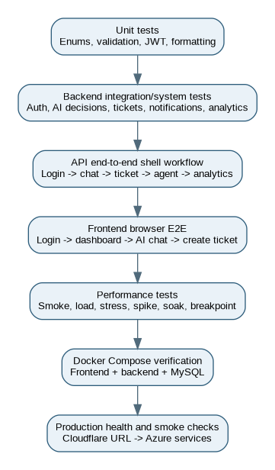
Figure 14: Testing workflow from unit and integration testing through end-to-end, performance and deployment verification.

Backend Automated Testing
The backend contains automated JUnit tests covering the main business rules and API workflows. The final test source includes 10 Java test classes, including a shared abstract system-test base class, with 80 @Test methods. Coverage includes authentication, authorisation, customer chat, ticket processing, agent and administrator workflows, AI decisions, validation, JWT handling and external AI fallback behaviour.
Test Area | Main Coverage
Authentication and Security | Registration, login, inactive users, invalid tokens, role restrictions, resource ownership and protected endpoints.
Customer Chat and Tickets | AI chat, knowledge-base responses, ticket creation, escalation, ownership, follow-up messages and ticket lifecycle.
Agent and Administrator Workflow | Agent assignment, replies, status changes, notifications, user administration, knowledge base, analytics and system logs.
API Errors and CRUD | Invalid input, malformed requests, enum errors, missing resources and CRUD validation.
AI Decision Integration | Scope handling, categories, priority, sentiment, confidence and escalation decisions.
Unit Validation | Enum handling, validation boundaries and JWT behaviour.
AI Resilience | Local fallback behaviour when the external AI provider is unavailable.
Application Context | Successful loading of the Spring Boot application context.
These tests verify both individual business rules and workflows involving multiple backend components.
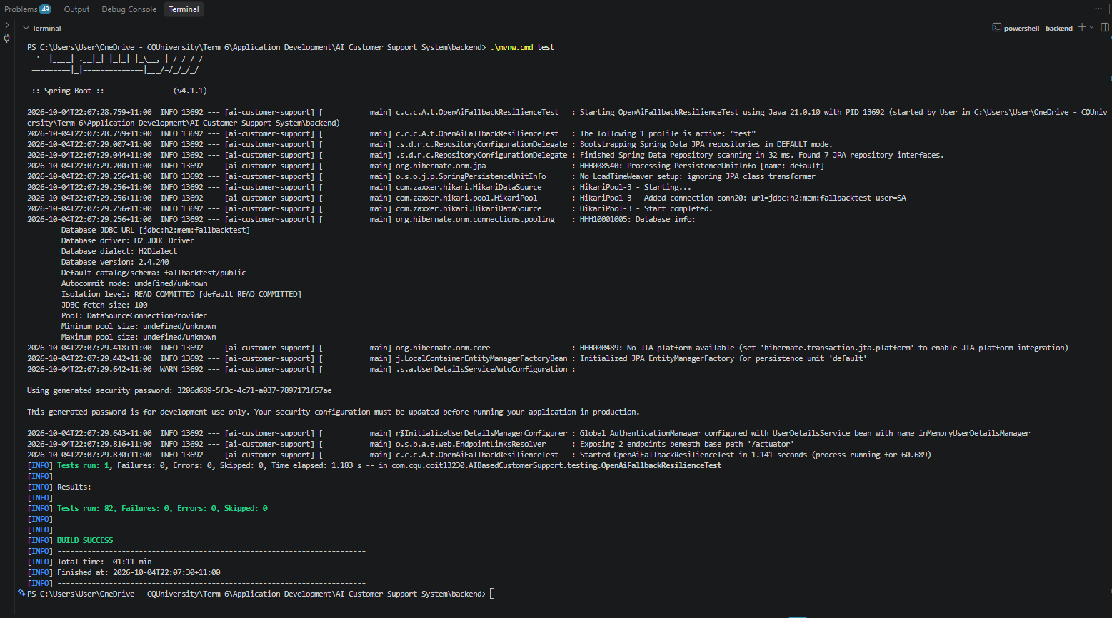
Figure 14: Backend automated test execution results for the final prototype.

Frontend Unit and Integration Testing
The frontend includes automated tests for the API client, response normalisation, formatting utilities and reusable React components. These tests verify behaviours such as authentication-token handling, API errors, validation responses, consistent ticket/user/notification data structures and reusable interface behaviour.
Frontend integration testing was particularly important because several differences between temporary frontend data structures and the actual backend responses were identified during integration. Response normalisation and centralised API handling were introduced to provide more consistent communication between the React application and Spring Boot APIs.
Where possible, the final frontend test execution should also be captured and included as evidence.
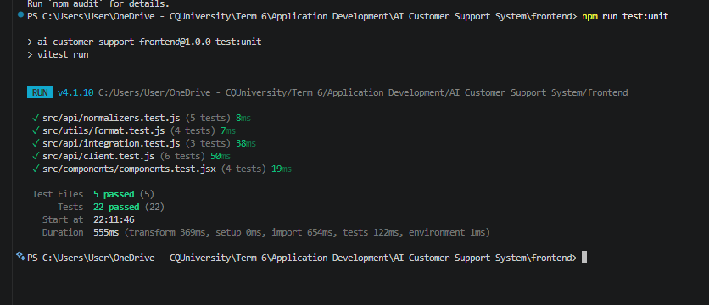
Figure 15: Frontend unit and integration test execution results.

Integration and End-to-End Testing
Integration testing verifies that the major components operate together rather than only testing individual methods or classes. The backend system tests exercise workflows across controllers, services, repositories, security and persistence, while API and browser-based end-to-end tests verify complete user interactions.
It also checks role restrictions, invalid requests and knowledge-based operations. This provides evidence that the main customer-support workflow operates across multiple backend modules.
Browser-based frontend testing verifies user-facing interactions such as login, dashboard access, AI-assisted chat, ticket creation and navigation to ticket details. A controlled test environment allows the frontend workflow to be tested consistently without relying entirely on the availability of an external AI provider.

Performance and Reliability Testing
Performance-testing assets were created to evaluate system behaviour under different levels of activity. Backend performance scenarios include smoke, load, stress, spike, soak and breakpoint testing, together with AI/chat and concurrent ticket scenarios. Frontend performance checks evaluate page-loading behaviour and resource usage.
Reliability testing also considers external AI-service failure. The application includes timeout and fallback behaviour so that an unavailable external provider does not necessarily cause the entire customer-support workflow to fail.
The performance scripts define measurable thresholds and workloads; however, numerical performance results should only be reported where the corresponding test execution output has been captured. Therefore, the presence of a performance-test script is treated as evidence of testing capability, while actual measured results are reported separately when execution evidence is available.

Testing Against Project Risks
Testing was also mapped to major technical risks identified during development.
Project Risk | Testing / Control
Unauthorised access | Authentication, role-matrix, token-rejection, ownership and protected-route tests.
External AI failure | Timeout handling and AI fallback/resilience testing.
Incorrect AI decisions | Tests for category, priority, sentiment, confidence and escalation rules.
Invalid API input | Bean validation, malformed-request, enum and CRUD error tests.
Frontend-backend mismatch | Response normalisation, API integration tests and browser workflow testing.
Performance degradation | Smoke, load, stress, spike, soak and breakpoint test scenarios.
Regression after integration/refactoring | Repeatable backend, frontend and end-to-end automated tests.
Overall, the testing strategy progressed from basic component verification to a broader approach covering security, business rules, AI-assisted decisions, integration, complete user workflows, resilience and performance. This provides stronger evidence that the final prototype was tested as an integrated customer-support application rather than as separate frontend, backend and AI components.

Docker, Containerisation and Production Deployment

Local Containerisation
Docker Compose defines three main services: MySQL 8.4, the Spring Boot backend and the React/Nginx frontend. The MySQL container uses a persistent named volume and health check, while the backend waits for MySQL to become healthy before starting. Database, JWT, CORS and AI configuration are supplied through environment variables. The backend exposes port 8080, while the frontend builds the Vite application and serves it through Nginx on port 80, normally mapped to port 8081 for local Docker use.
This configuration provides a repeatable full-stack environment across development machines. H2 remains available for fast local backend development and testing, while MySQL provides the persistent database environment used by Docker and production.

Nginx Reverse Proxy
The production frontend container uses Nginx to serve the React single-page application and proxy backend requests. Requests to /api and /actuator are forwarded to the configured backend URL, while other requests are served by the React application with an index.html fallback for client-side routing.
The Nginx configuration also provides static-asset caching and basic security headers. HTTPS proxy configuration was included for communication with the backend environment. This configuration was refined during deployment after gateway and CORS issues were identified.

Azure Deployment
The final cloud deployment uses Azure Container Registry, Azure Container Apps and Azure Database for MySQL Flexible Server. Versioned frontend and backend container images can be stored in the registry and deployed to separate container applications.
The backend connects to the managed MySQL database and can use the configured external AI service. Environment-specific configuration and credentials are supplied at runtime rather than being hard-coded into the application source code.

Cloudflare Public URL
The deployed application is accessible through the public Cloudflare Worker URL:
https://app.aics-050.workers.dev
The application provides the /login interface for user authentication, while the /actuator/health endpoint provides a health check for the deployed backend.
The Cloudflare public entry point provides a stable demonstration URL while the application services remain hosted in the Azure environment.
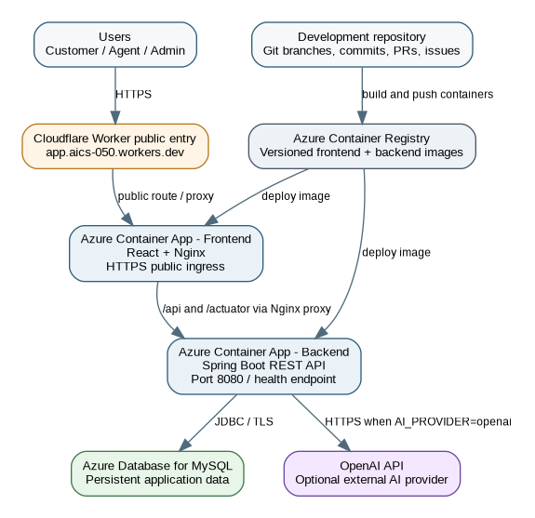
Figure 16: Final production deployment showing the Cloudflare public entry point, Azure container services, MySQL database and external AI service.

Deployment Problems and Refinement
Deployment identified several issues that were not visible during local development. These included Nginx configuration, environment configuration, CORS behaviour and gateway communication.
A key issue occurred when the application was accessed through the public Cloudflare URL. The production CORS configuration needed to recognise the public origin, while the Nginx frontend proxy needed to forward browser API requests correctly to the backend. Deployment troubleshooting also highlighted the importance of health endpoints, correct internal service configuration and appropriate proxy timeouts.

Evaluation of the Final Solution
The final solution was evaluated against the original project objectives, functional requirements and success criteria. Overall, the project produced a functional and integrated prototype combining AI-assisted customer support, automated ticket management, human escalation, role-based security, analytics and cloud deployment. Most functional objectives were implemented successfully; however, quality targets that require measured runtime evidence are evaluated separately from functionality that can be directly demonstrated.
Original Objective | Final Evidence | Evaluation
AI-powered chatbot | Customer chat interface, AI services, knowledge-base support, structured responses and fallback behaviour. | Implemented
Automated ticket management | Manual and automated ticket creation, classification, priority assignment, status management, agent assignment and ticket history. | Implemented
Sentiment analysis | Sentiment classification and scores integrated into AI-assisted processing and testing. | Implemented
Intelligent human escalation | Confidence, sentiment, priority and human-request conditions support escalation decisions and reasons. | Implemented
Customer and agent workflow | Customers can create and track tickets, while agents can review, respond to and resolve escalated cases. | Implemented
Analytics and reporting | Administrator analytics endpoints, reporting functionality and frontend analytics interface. | Implemented
Secure access | JWT authentication, BCrypt password hashing, role-based access control, resource ownership controls and protected routes. | Implemented for prototype scope
Response under 3 seconds | Performance-testing assets and timeout controls were implemented. | Requires final measured evidence
Deployable system | Docker containerisation, Nginx routing, Azure services, MySQL persistence and public deployed application. | Implemented / Deployed

Strengths of the Final Design
- Structured AI output connects AI results with application business rules rather than relying only on unrestricted generated text.
- External AI communication is separated from core application logic and supported by local fallback behaviour.
- Human escalation uses identifiable conditions including confidence, sentiment, priority and direct requests for human assistance.
- JWT authentication and role-based access control protect backend functionality and are reflected through role-aware frontend navigation.
- The application follows a modular structure across the frontend, backend, AI, persistence and security layers.
- Automated testing covers security, validation, AI decisions, ticket workflows, integration and end-to-end scenarios.
- Docker-based deployment and production routing support consistent execution across local and cloud environments.

Limitations
- AI-assisted responses and decisions remain dependent on the quality of the customer input, prompts, available knowledge and configured business rules; unusual enquiries may therefore not always be classified correctly.
- Local fallback processing is intentionally simpler than the external AI model and cannot provide the same level of language understanding.
- Complete measured results have not been retained for every performance-testing scenario; therefore, performance targets should not be considered fully demonstrated without execution evidence.
- A complete automated CI/CD pipeline was not implemented within the prototype and remains suitable future work.
- As an academic prototype, the application does not implement all enterprise-level compliance, production observability, data-retention and operational-governance controls.
- Voice support, multilingual assistance, native mobile applications, video support and payment processing remain outside the implemented project scope.

Ethical, Security and Professional Considerations
The use of AI and customer information introduces ethical, privacy and security responsibilities. The project therefore considered data minimisation, AI reliability, human oversight, secure credential handling and responsible software-development practices as part of the final solution.

Privacy and Data Minimisation
Customer-support messages may contain personal or account-related information. The system should therefore collect and process only the information required for the support workflow. Development and testing should use synthetic or non-sensitive data where possible, while information sent to an external AI provider should be limited to what is necessary to process the customer enquiry.
Access to stored support information is also restricted according to the authenticated user's role and relationship to the resource, reducing unnecessary access to customer information.

AI Reliability, Transparency and Human Oversight
AI-generated responses and classifications may be incorrect or uncertain. The prototype reduces this risk through confidence assessment, knowledge-base support, structured AI results, business rules and human escalation. (Dwivedi et al., 2021)
Inquires requiring additional attention can be transferred to a support agent rather than relying entirely on automated decision-making. This maintains human oversight for complex, uncertain or sensitive customer-support situations and supports the project's original objective of balancing AI automation with human assistance. (Huang and Rust, 2023)

Prompt Injection and Scope Control
Customer input is treated as untrusted content and should not be allowed to modify the intended behaviour of the AI-assisted support system. The prototype includes scope controls and testing for inappropriate or unrelated requests so that the chatbot remains focused on customer-support activities rather than functioning as an unrestricted general-purpose assistant.
Testing of out-of-scope and potentially manipulative inputs also helps verify that inappropriate requests do not interfere with the intended customer-support workflow.

Credential and Secret Management
Sensitive configuration such as JWT secrets, database credentials and external AI API keys is managed through environment-based configuration rather than being hard-coded into the application source code.
Example configuration files should contain placeholder values, while production credentials should be securely configured in the deployment environment. Sensitive credentials should not be committed to GitHub or included in distributable project files, supporting safer development and deployment practices.

Professional Practice
The team used GitHub issues, branches, commits, pull requests, meeting records, documentation and testing evidence to maintain accountability and traceability throughout development. Responsibilities were divided across backend/database, frontend/UI and AI integration while regular communication supported integration of the three development streams.
Problems, requirement changes and design refinements were documented as the project progressed rather than being left unexplained. This allowed the final implementation to be compared with the original requirements and provided evidence of responsible project management, collaborative development, testing and continuous refinement

Problems Encountered and Resolutions
Several technical and integration problems were encountered as the frontend, backend and AI components were combined into the final prototype. These problems were addressed through refactoring, additional validation, testing and deployment configuration.
Problem Encountered | Resolution / Project Response
External AI service availability and configuration | External AI communication was separated from core business logic, with request timeouts and local fallback behaviour added to improve reliability.
AI responses needed to support ticket business logic | AI processing was refined to produce structured information including category, priority, sentiment, confidence and escalation decisions rather than conversational text alone.
Frontend and backend response mismatch | Frontend API integration was refactored, and response normalisation was introduced to provide consistent data structures across pages.
Out-of-scope customer messages | Scope handling was improved so unrelated requests could be handled safely without incorrectly creating support conversations or tickets, with regression tests added for this behaviour.
Role and resource-ownership complexity | Backend RBAC, authenticated-user checks and ticket ownership validation were strengthened and supported with dedicated security tests.
Notification read/unread behaviour | Notification APIs and frontend mark-as-read behaviour were refined to maintain consistent unread notification state.
Deployment gateway and CORS issues | Nginx proxy configuration, production CORS settings and Azure service configuration were refined to support communication through the deployed application.
Integration after parallel branch development | Frontend, backend and AI components were progressively merged, refactored and documented before final testing and deployment.
Limited automated testing during earlier development | Backend, frontend, integration, end-to-end and performance-testing assets were expanded during the final testing and hardening stage.
The problems encountered demonstrate the importance of continuous integration and testing in a multi-component application. Several issues only became visible after independently developed frontend, backend and AI components began operating together.

Final Project Outcomes
The final outcome is an integrated full-stack AI-assisted customer-support application that demonstrates the major stages of the project lifecycle, including requirements analysis, system design, implementation, integration, testing, security, project management and deployment.
The system progressed beyond the initial concept of an AI chatbot into a complete customer-support workflow. Customers can authenticate, interact with AI-assisted support, create and monitor tickets and receive responses. Customer enquiries can contribute to structured category, priority, sentiment, confidence and escalation decisions, while persistent conversations and ticket histories allow support agents to continue cases requiring human assistance. Administrators are provided with additional functionality for user management, knowledge-base maintenance, analytics and system monitoring.
The project also produced supporting artefacts including functional and non-functional requirements, UML diagrams, database design, risk analysis, API documentation, source-code documentation, automated tests, meeting records, GitHub development history, Docker configuration and cloud-deployment configuration. Together, these artefacts demonstrate the progression from the original proposal to the current integrated prototype.

Future Improvements
Although the current prototype implements the main project objectives, several improvements could increase its automation, scalability, security and production readiness:
- Introduce a CI/CD pipeline using GitHub Actions or Azure DevOps to automatically execute tests, build container images and deploy approved releases.
- Strengthen production secret management using Azure Key Vault and managed identities where appropriate.
- Improve database and backend network security through private networking and more restrictive service access.
- Preserve performance-test results as versioned artefacts so that performance can be compared between releases.
- Develop a larger labelled evaluation dataset to measure AI category, sentiment, priority and escalation accuracy.
- Extend customer interaction through multilingual and voice support after the core support workflow is stable.
- Consider future integration with external CRM or enterprise customer-service platforms.
- Improve production observability using centralised logging, metrics, alerts and request correlation.
- Introduce formal data-retention, privacy-notice and data-deletion workflows for production use.

Conclusion
The AI-Based Customer Support Automation System progressed from an identified customer-support problem into an integrated and deployable prototype. The original proposal identified the need to reduce repetitive support work, improve response efficiency and provide better management of customer enquiries. These objectives were translated into functional and non-functional requirements, system designs and implementation tasks across the frontend, backend, database and AI components.
The final prototype combines AI-assisted chat, automated ticket management, classification and prioritisation, sentiment and confidence analysis, human escalation, notifications, knowledge-base management, analytics and role-based security. CLIENT, AGENT and ADMIN workflows are integrated through the React frontend and Spring Boot backend, with persistent storage supporting conversations, messages, tickets and related system information.
A key outcome of the project is the integration of AI with conventional software-engineering controls. AI output is used alongside structured results, application business rules, confidence assessment, knowledge-base information and human escalation, rather than relying entirely on unrestricted generated responses. This allows automated assistance to support routine customer enquiries while retaining human involvement when required.
Development was supported by GitHub-based project tracking, regular team meetings, incremental integration and automated testing. Testing expanded to cover authentication and security, customer and agent workflows, AI decisions, validation, resilience, integration and end-to-end behaviour. Docker-based containerisation and cloud deployment further demonstrated that the prototype could operate beyond the local development environment.
Some limitations remain, particularly around comprehensive measured performance evidence, automated CI/CD and production-level governance and observability. These provide clear opportunities for future development. Overall, the project achieved its main functional objectives and original success criteria and demonstrates a complete progression from proposal and system design through implementation, integration, testing and deployment.

References
Ale, A., Bhandari, A. and Bhandari, P. (2026) AI-Based Customer Support Automation System: Assessment 1 – Group Project Proposal. COIT13230 Application Development Project, CQUniversity. Supplied project document.
AI-Based Customer Support Automation System (2026a) System Analysis and Design. Supplied project document.
AI-Based Customer Support Automation System (2026b) Task Division: AI-Based Customer Support Automation System. Supplied project document.
AI-Based Customer Support Automation System (2026c) Meeting Minutes 1–9. Supplied project records.
AI-Based Customer Support Automation System (2026d) Final source archive and Git repository history, reviewed 29 September 2026. Supplied project artefact.
Bhandari, A. (2026a) Individual Reflection and Learning Plan. COIT13230 Application Development Project. Supplied individual document.
Bhandari, A. (2026b) Individual Project Progress Report 1. COIT13230 Application Development Project. Supplied individual report dated 17 August 2026.
Bhandari, A. (2026c) Individual Project Progress Report 2. COIT13230 Application Development Project. Supplied individual report dated 14 September 2026.
Brandtzaeg, P.B. and Følstad, A. (2017) ‘Why people use chatbots’, in Internet Science. Cham: Springer, pp. 377–392. doi:10.1007/978-3-319-70284-1_30.
Dlodlo, D. and Sibanda, K. (2023) ‘Automated ticket classification for information technology helpdesks using machine learning’, 2023 2nd Zimbabwe Conference of Information and Communication Technologies, pp. 1–7. doi:10.1109/ZCICT59466.2023.10528578.
Dwivedi, Y.K. et al. (2021) ‘Artificial Intelligence (AI): Multidisciplinary perspectives on emerging challenges, opportunities, and agenda for research, practice and policy’, International Journal of Information Management, 57, p. 101994. doi:10.1016/j.ijinfomgt.2019.08.002.
Følstad, A. and Skjuve, M. (2019) ‘Chatbots for customer service: User experience and motivation’, Proceedings of the 1st International Conference on Conversational User Interfaces, pp. 1–9. doi:10.1145/3342775.3342784.
Gnewuch, U., Morana, S. and Maedche, A. (2017) ‘Towards designing cooperative and social conversational agents for customer service’, Proceedings of the 38th International Conference on Information Systems.
Huang, M.H. and Rust, R.T. (2023) ‘The caring machine: Feeling AI for customer care’, Journal of Marketing, 88(5). doi:10.1177/00222429231224748.
Kitsios, F. and Kamariotou, M. (2021) ‘Artificial intelligence and business strategy towards digital transformation: A research agenda’, Sustainability, 13(4), p. 2025.
Mao, Y., Liu, Q. and Zhang, Y. (2024) ‘Sentiment analysis methods, applications, and challenges: A systematic literature review’, Journal of King Saud University – Computer and Information Sciences, 36(4), p. 102048. doi:10.1016/j.jksuci.2024.102048.
Olujimi, P.A. and Ade-Ibijola, A. (2023) ‘NLP techniques for automating responses to customer queries: A systematic review’, Discover Artificial Intelligence, 3(1). doi:10.1007/s44163-023-00065-5.
Taherdoost, H. and Madanchian, M. (2023) ‘Artificial intelligence and sentiment analysis: A review in competitive research’, Computers, 12(2), p. 37. doi:10.3390/computers12020037.
Uzan, S., Freud, D. and Elalouf, A. (2025) ‘Optimizing chatbots to improve customer experience and satisfaction: Research on personalization, empathy, and feedback analysis’, Applied Sciences, 15(17), p. 9439. doi:10.3390/app15179439.
Zangari, A., Marcuzzo, M., Schiavinato, M., Gasparetto, A. and Albarelli, A. (2023) ‘Ticket automation: An insight into current research with applications to multi-level classification scenarios’, Expert Systems with Applications, 225, p. 119984. doi:10.1016/j.eswa.2023.119984.

Appendix A – Final Technology and Artefact Inventory
A programmatic review of the final archive identified 206 meaningful files after excluding raw Git object storage, macOS AppleDouble copies and .DS_Store metadata. The following table summarises the main file groups. The review also inspected hidden environment/configuration files, but secret values are not reproduced in this report.
File group | Count | Purpose
Java (.java) | 89 | 79 production backend files and 10 test/support classes.
React JSX (.jsx) | 27 | Application pages, components and authentication context.
JavaScript (.js) | 19 | Frontend API/utilities/tests plus backend k6 performance tests.
PlantUML (.puml) | 10 | Version-controlled source for system design diagrams.
Word documents (.docx) | 12 | Proposal, requirements, API docs and meeting minutes inside the final archive.
PNG diagrams/images | 13 | System-design and risk artefacts.
YAML (.yml) | 5 | Spring application profiles, test configuration and related settings.
Docker/Nginx/shell/JSON/HTML/CSS/other | 21+ | Container builds, compose, reverse proxy, scripts, package metadata and UI styles.

Appendix A.1 Key Production Configuration Files
File | Purpose
docker-compose.yml | Runs MySQL, backend and frontend together with health/dependency configuration.
backend/Dockerfile | Builds/runs the Spring Boot backend container.
frontend/Dockerfile | Builds Vite output and packages it into an Nginx runtime.
frontend/nginx.conf | SPA hosting, /api and /actuator reverse proxy, TLS upstream SNI and security headers.
application.yml | Common server, JPA, JWT, CORS, AI and seed settings.
application-h2.yml / application-mysql.yml | Database-specific development and persistent runtime profiles.
.env.example files | Document required runtime settings without requiring secrets in source.
README.md | Complete developer, testing, Docker, Azure and troubleshooting guide.

Appendix B – Requirement Traceability Summary
Requirement group | Implementation evidence | Primary verification
FR1–FR7 Customer/chat | AuthController, ChatController, frontend login/register/chat, Conversation/Message models | AuthenticationAndSecuritySystemTest; CustomerChatTicketSystemTest; browser E2E
FR8–FR14 Tickets/classification | TicketService, customer/agent ticket controllers, Ticket model and enums | CustomerChatTicketSystemTest; AgentAdminWorkflowSystemTest; API E2E
FR15–FR17 Sentiment/confidence | AiService, AiAnalysisResponse | AiDecisionIntegrationTest
FR18–FR22 Escalation/agent | AgentTicketController, NotificationService, ticket assignment/status logic | AgentAdminWorkflowSystemTest; API E2E
FR23–FR25 Knowledge base | KnowledgeBaseController/Service/Repository | AgentAdminWorkflowSystemTest; API E2E
FR26–FR28 Analytics | AnalyticsController/Service and frontend AnalyticsPage | Analytics system tests; weekly/monthly E2E checks
FR29–FR33 Roles/admin/logging | SecurityConfig, UserService, AdminUserController, SystemLogService | Security/system tests and admin E2E
NFR1–NFR5 Performance/reliability | Timeouts, fallback, k6 scripts, health endpoint | Performance scripts; OpenAiFallbackResilienceTest
NFR6–NFR10 Security/privacy | JWT, BCrypt, RBAC, CORS, HTTPS deployment, env secrets | Security system tests and code review
NFR11–NFR20 Usability/extensibility/maintainability | React components, layered backend, provider separation, docs and Docker | Frontend tests, architecture review and final artefacts

Appendix C – Selected API Surface
The final controller source contains 67 mapped HTTP operations. The separate API documentation supplied with the project contains detailed request and response JSON examples. The table below highlights the main user-facing groups.
Area | Representative endpoints
Authentication | POST /api/auth/register; POST /api/auth/login; GET /api/auth/me
AI chat | POST /api/chat/messages
Customer tickets | GET /api/tickets/my; GET /api/tickets/my/summary; POST /api/tickets; GET /api/tickets/{id}; POST /api/tickets/{id}/messages
Agent tickets | GET /api/agent/tickets; PUT/PATCH assignment/status operations; POST agent ticket messages
Knowledge base | GET/POST /api/knowledge-base; PUT/DELETE /api/knowledge-base/{id}
Notifications | Customer/agent notification lists and mark-read operations
Admin users | GET/POST /api/admin/users; GET active agents; PUT/PATCH user updates
Analytics | Ticket summary/filter plus weekly/monthly reports
System operations | GET /api/system-logs; GET /actuator/health

Appendix D – Deployment and Submission Checklist
- Keep real .env files and API/database secrets out of distributable source archives; rotate any credential that may have been exposed.
- Run backend automated tests and frontend tests before creating a release image.
- Build both Docker images and verify the full stack with Docker Compose.
- Check /actuator/health through the same public path used by the frontend.
- Confirm CORS_ALLOWED_ORIGINS includes the real public production origin when direct cross-origin access is possible.
- Confirm frontend BACKEND_API_URL points to the correct internal Azure backend service and Nginx can resolve it.
- Store production JWT, database and OpenAI values as managed container/cloud secrets.
- Preserve test reports or console outputs with the submitted evidence, especially for performance tests.
- Tag or otherwise identify the exact commit/image versions used for the final demonstration.

